CN LAB PROJECT

GROUP MEMBERS:
Shaiza Parveen (F20242661332) — Security Validation Analyst
Amna Nasrullah (F2024266096) — Configuration Lead
M Haris Usman (F2024266948) — Risk & Resource Analyst / Deployment Lead

SUBMITTED TO :
Sir Tahir Mahmood

1. Device Identification & Initial Observation
Initial scrutiny of the unfiltered network capture reveals a single internal node actively flooding the network with rapid, high-volume outbound synchronization packets targeting TCP Port 23 (Telnet) — a textbook Mirai botnet indicator.

Compromised Device IP: 192.168.100.103
Compromised Device MAC: b8:27:eb:c7:e9:c9
Device Type: Raspberry Pi — Homeowner's Smart IoT Node

Evidence 1

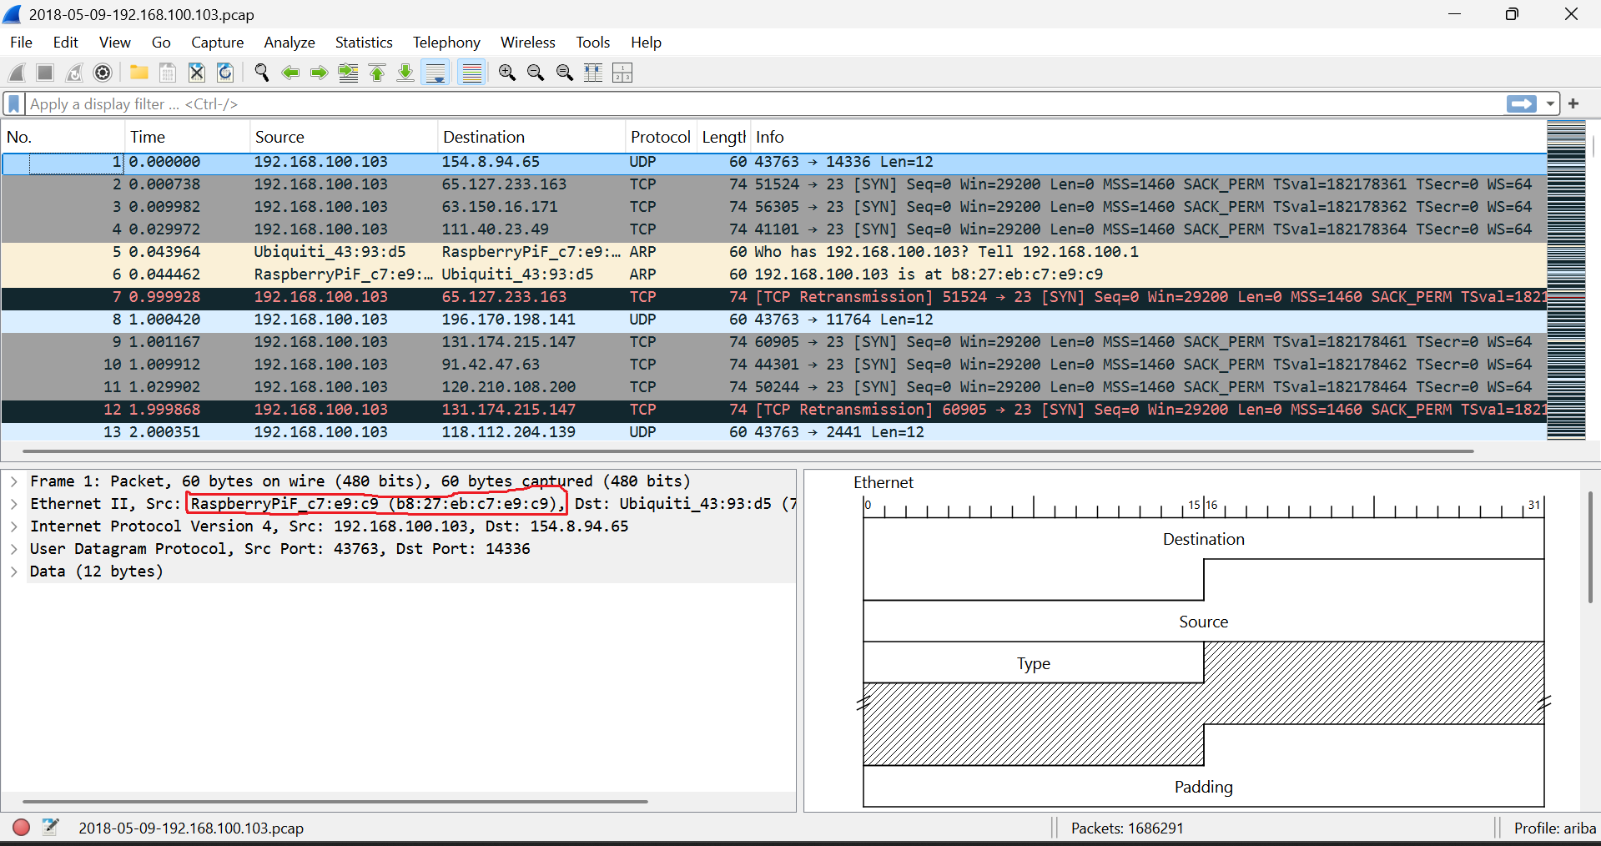

2. Security Investigation & Attack Analysis
A Telnet display filter was applied in Wireshark to isolate the direct interactive paths of threat actors and suppress background protocol noise.

Attack Vector: Telnet Protocol (TCP Port 23)
Primary C2 Server IP: 219.243.27.65
Secondary Threat IP: 71.181.6.40
The external IP 219.243.27.65 acts as the primary orchestrator pushing inbound payloads into the Raspberry Pi. IP 71.181.6.40 appears in concurrent unencrypted paths, signaling a distributed multi-tiered malicious server pattern.

Evidence 2
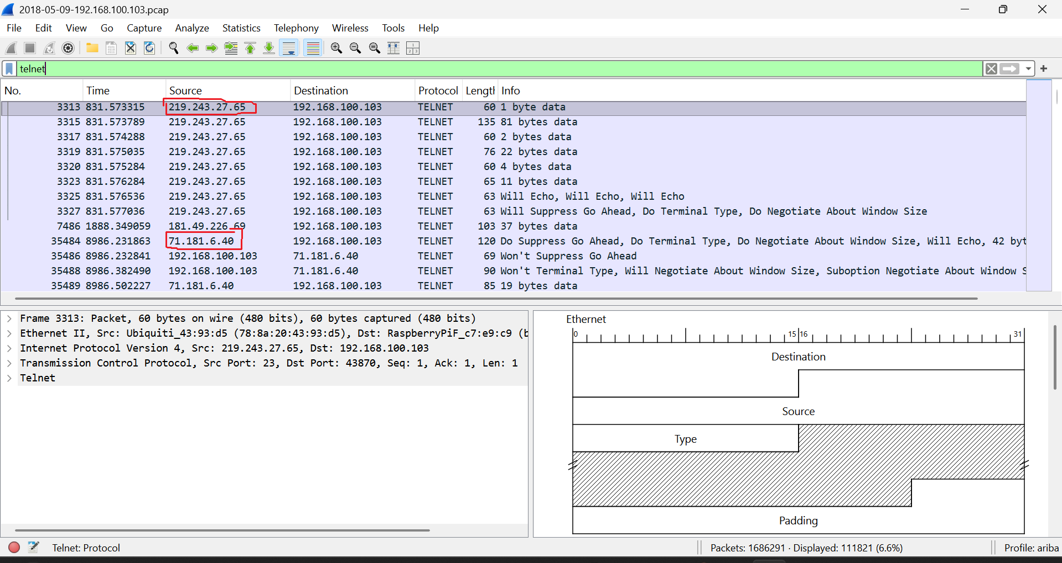

3. Credential Recovery Analysis
Because Telnet transfers data completely unencrypted, Wireshark's TCP Stream feature (Stream 5119) was used to extract the interactive terminal session, exposing the attacker's dictionary attempts.

Attempt 1: Username: root | Password: 123456 | Result: Bad username/Password
Attempt 2: Username: enable | Password: system | Result: Bad username/Password
Attempt 3: Username: shell | Password: sh | Result: Bad username/Password

Forensic Conclusion: All brute-force attempts failed. However, thousands of concurrent streams confirm the network remained under severe dictionary testing.

Evidence 3
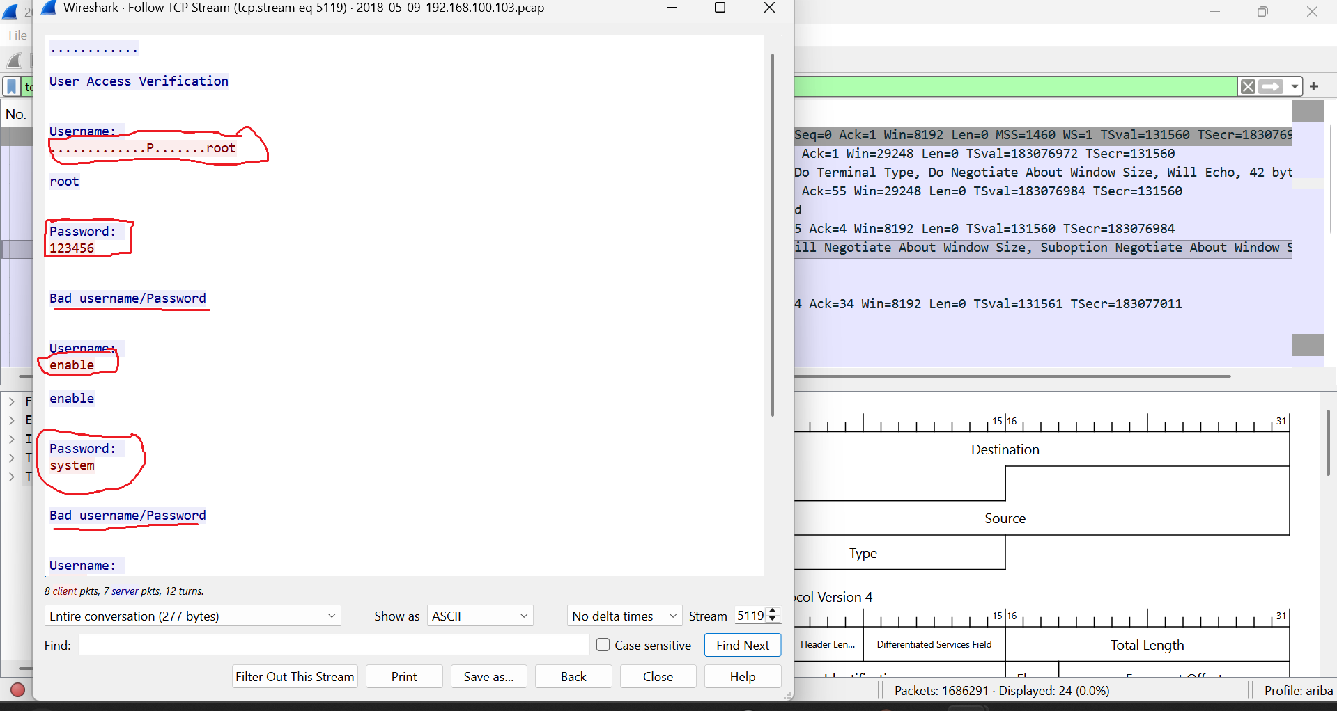

4. Artifact Tables & System Data
Table 1: Indicators of Compromise (IOC)
Indicator Type | Value | Context / Description
Infected Device IP | 192.168.100.103 | Victim smart IoT device (Raspberry Pi) generating malicious outbound traffic.
Infected Device MAC | b8:27:eb:c7:e9:c9 | Physical hardware address of the compromised Raspberry Pi.
Primary C2 Server IP | 219.243.27.65 | Active external C2 node interacting with the victim via Telnet.
Secondary Threat IP | 71.181.6.40 | Additional external host in concurrent unencrypted communication paths.
Target Protocol/Port | TCP Port 23 (Telnet) | Unsecured vector exploited for password dictionary attacks.

Table 2: Incident Timeline
Timestamp (s) | Source IP | Destination IP | Event Description
0.000000 | 192.168.100.103 | 154.8.9.65 | Initial outbound UDP connection attempt, signaling start of capture.
0.000738 | 192.168.100.103 | 65.127.233.163 | Victim initiates rapid [SYN] scanning on Port 23 (Telnet), confirming infection.
0.044462 | 192.168.100.103 | Local Network | ARP broadcast linking IP to Raspberry Pi hardware MAC address.
831.573315 | 219.243.27.65 | 192.168.100.103 | C2 Server establishes inbound Telnet stream (Stream 5119), triggering auth prompt.
831.574288 | 219.243.27.65 | 192.168.100.103 | Attacker executes automated dictionary-based brute-force password attempts.
831.575035 | 192.168.100.103 | 219.243.27.65 | Device responds with Bad username/Password, failing the login session.

Table 3: IP Addressing Plan
Device Name | IP Address | MAC Address | Subnet Mask | Gateway | Role
Home Router | 192.168.100.1 | 78:8a:20:43:93:d5 | 255.255.255.0 | 0.0.0.0 | Default Gateway / Wireless AP
Smart IoT Node | 192.168.100.103 | b8:27:eb:c7:e9:c9 | 255.255.255.0 | 192.168.100.1 | Victim Raspberry Pi — Botnet Traffic
Primary C2 Server | 219.243.27.65 | N/A (External) | N/A (WAN) | N/A | Telnet brute-force C2
Secondary Threat | 71.181.6.40 | N/A (External) | N/A (WAN) | N/A | Secondary attack source

5. Root Cause & Architectural Mitigation
The root cause is deployment of an IoT device running unencrypted Telnet (TCP Port 23) without any firewall protection or access control.
- Disable Telnet service (TCP Port 23) on all IoT devices immediately.
- Enforce SSH key-based authentication with complex, non-default passwords.
- Isolate all smart devices within a dedicated, restricted Guest VLAN.

6. Github link:
https://github.com/shaiza124/CN-LAB-Problem-7.git

7. Resource Acquisition Report
- Wireshark Version 4.0+ — Network protocol analyzer for PCAP examination. Source: wireshark.org
- PCAP Evidence File (2018-05-09-192.168.100.103.pcap) — Captured network traffic from compromised IoT environment. Provided as part of Problem 7 assignment.
- Hardware/Environment — Windows/Linux workstation for running Wireshark analysis.

8. Risk Assessment Matrix
ID | Risk Description | Likelihood | Impact | Risk Level | Mitigation Strategy
R-001 | Cleartext Telnet Management (Port 23 Enabled) | High | Critical | HIGH | Disable Telnet immediately; enforce SSH key-based authentication.
R-002 | Weak/Default Device Password Storage | High | High | HIGH | Replace all default credentials with complex alphanumeric passwords.
R-003 | Unsegmented IoT Deployment | Medium | High | MED-HIGH | Segment smart nodes within a restricted Guest VLAN.

9. Network Topology
